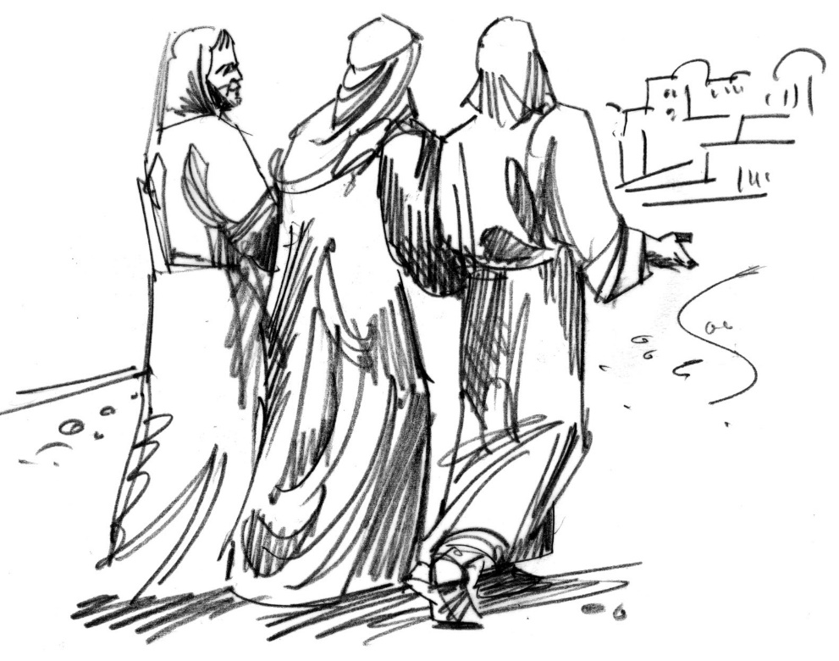

Jesus Appears on the Road to Emmaus

Third Sunday of Easter
April 23, 2023

Welcome! We are glad you are here! In worship, we gather before the almighty God to offer him the praise that is due his name and to be fed by his life-giving Word. This service folder will guide you through our path of worship. If you have any questions, please don’t hesitate to ask an usher or the person sitting next to you. God bless your time in this house of God.

Bathrooms are located in the fellowship hall. A changing table is located in the women’s bathroom.

A worship monitor is to the right as you exit. We encourage children of all ages to participate in our worship. Please bring them into the service. We have a nursery room with toys, books, and other items that you can use with your child.
Before you leave, please sign our guest register. Located on the lectern in the entryway.

OPENING HYMN Every Morning Mercies New CW580

M: O Lord open my lips
C: And my mouth shall declare your praise.

M: Hasten to save me, O God.
C: O Lord, come quickly to help me.

M: Give glory to God, our light and our life.
C: Come, oh, come, let us worship.

COME, OH COME

C: ♫ (2x) Come, oh, come let us sing to the Lord, let us shout with joy to our saving Rock; come, enter in with our songs of praise, come enter in with thanksgiving.

C: ♫You are a great and a wondrous God, cupping in your hands all the depths of earth. You made the hills and the mountains high, you made the seas and the dry land.
C: ♫ Come, oh, come let us sing to the Lord, let us shout with joy to our saving Rock; come, enter in with our songs of praise, come enter in with thanksgiving.
C: ♫ Come, let us worship and, bowing low, kneel before the One who has made us all. You are the God whom we call our own, we are the flock that you shepherd.
C: ♫ Come, oh, come let us sing to the Lord, let us shout with joy to our saving Rock; come, enter in with our songs of praise, come enter in with thanksgiving. Come enter in with thanksgiving. Come enter in with thanksgiving.

The Word

FIRST LESSON Acts 21:14a, 32-41

PSALM OF THE DAY Psalm 67 (CW pg. 91)

SECOND LESSON 1Peter 1:17-21

GOSPEL ACCLAMATION
M: Alleluia. Were not our hearts burning within us while he talked with us on the road and opened the Scriptures to us? Alleluia.

SEASONAL RESPONSE
C: ♫ Alleluia! Alleluia! Alleluia! These words are written that we may believe that Jesus is the Christ, the Son of God. Alleluia! Alleluia! Alleluia!

GOSPEL Luke 24:13-35
HYMN This Joyful Eastertide CW 160
SERMON
CONFESSION OF FAITH: 2nd Article with Explanation

C: I believe in Jesus Christ, his only Son, our Lord, who was conceived by the Holy Spirit, born of the virgin Mary, suffered under Pontius Pilate, was crucified, died, and was buried. He descended into hell. The third day he rose again from the dead. He ascended into heaven and is seated at the right hand of God the Father almighty. From there he will come to judge the living and the dead.

M: What does this mean?
C: I believe that Jesus Christ, true God, begotten of the Father from eternity, and also true man, born of the virgin Mary, is my Lord. He has redeemed me, a lost and condemned creature, purchased and won me from all sins, from death, and from the power of the devil, not with gold or silver but with his holy, precious blood and with his innocent suffering and death. All this he did that I should be his own and live under him in his kingdom and serve him in everlasting righteousness, innocence, and blessedness, just as he has risen from death and lives and rules eternally.
This is most certainly true

YOU ARE GOD; WE PRAISE YOU
C: ♫ You are God; we praise you. You are Lord; we acclaim you. To you O Father holy, all creation offers praise.
M: ♫ With the angels in heaven
C: ♫ We praise you, we praise you!
M: ♫ With the cherubim and seraphim,
C: ♫ We praise you, we praise you!
M: ♫ With the apostles and prophets,
C: ♫ We praise you, we praise you!
M: ♫ With the martyrs and your holy Church,
C: ♫ We sing in endless praise!

C: ♫ You are God; we praise you. You are Lord; we acclaim you. To you O Father holy, all creation offers praise.

M: ♫ Creator of all things.
C: ♫ We praise you, we praise you!
M: ♫ O Jesus Christ, the Son of God,
C: ♫ We praise you, we praise you!
M: ♫ O Spirit, most holy,
C: ♫ We praise you, we praise you!
M: ♫ To the Trinity most blessed,
C: ♫ We sing in endless praise!

C: ♫ You are God; we praise you. You are Lord; we acclaim you. To you O Father holy, all creation offers praise.

M: ♫ O Christ, King of Glory.
C: ♫ We praise you, we praise you!
M: ♫ You became a man to set us free;
C: ♫ We praise you, we praise you!
M: ♫ You have risen to free us;
C: ♫ We praise you, we praise you!
M: ♫ And with all your saints in glory,
C: ♫ We sing in endless praise!

C: ♫ You are God; we praise you. You are Lord; we acclaim you. To you O Father holy, all creation offers praise, all creation offers praise, all creation offers praise.

OFFERING We joyfully respond to our Shepherd’s loving care by praising him with all we are and all we have. Bringing an offering is an act of trust in God’s promises to provide and an acknowledgement that “my cup overflows.” A joyful and generous offering is always a wonderful way to show Jesus that he is our greatest treasure and worthy of our praise. May God be praised through our offerings!

LORD, HAVE MERCY

M: ♫ In the morning, O Lord, I call to you; be merciful to me and hear my prayer.
C: ♫ Lord, have mercy, Christ, have mercy. Lord, have mercy.

PRAYER OF THE CHURCH

M: Stay with us, Lord. Make our hearts burn within us as you open the Scriptures to us.
We call on the name of the Lord:
C: Lord, save us!
M: Sometimes our tears keep us from recognizing you, and we are slow to believe what the Scriptures say about you. Open our eyes, that we may see you walking with us, and open our mouths to confess your love.
We call on the name of the Lord:
C: Lord, save us!

M: Call those who do not know you with your holy gospel, that people near and far may repent and be baptized in your name for the forgiveness of their sins.
We call on the name of the Lord:
C: Lord, save us!
M: We give our thanks to you for all of your blessings, and we pray that you would bless those who plow and plant, so that we may receive our daily bread from your hand.
We call on the name of the Lord:
C: Lord, save us!
M: Give boldness and confidence to those who share the warning of your law and the comfort of your gospel, that many may be added to the number of your believers.
We call on the name of the Lord:
C: Lord, save us!
M: Protect and save those who are brought low by the burdens of life, [especially…]. Lead them to trust in you in their afflictions. Deliver them, wipe all tears from their eyes, and keep their feet from stumbling.
We call on the name of the Lord:
C: Lord, save us!
Special prayers and intercessions may follow.

M: Listen, Lord, to the thoughts and cares of our hearts.

Silent prayer

M: Jesus, our Master, meet us while we walk in the way, yearning to reach the heavenly country, so that following your light, we may stay on the path of righteousness, and never wander away into the darkness of this world’s night while the light of your Word is shining within us; you live and reign, now and forever.

C: Amen.

C: Our Father, who art in heaven, hallowed be thy name, thy kingdom come, thy will be done on earth as it is in heaven. Give us this day our daily bread; and forgive us our trespasses, as we forgive those who trespass against us; and lead us not into temptation, but deliver us from evil. For thine is the kingdom and the power and the glory forever and ever. Amen

M: ♫ Let us praise the Lord.
C: ♫ Thanks be to God.

BLESSING

M: ♫ The Lord bless and keep you.
C: ♫ Amen.

M: ♫ The Lord’s face evershine upon you.
C: ♫ Amen.

M: ♫ The Lord grant you peace for all your days.
C: ♫ Amen.

CLOSING HYMN God of Mercy, God of Grace CW249

Come worship with us again!
Next Sunday, April 30TH - 2:00 pm

VACANCY PASTOR

Christopher Hoppe, Pastor stjohnluthvaca@outlook.com
(920) 652-4003 www.stjohnvacaville.org
christopherhpp@gmail.com

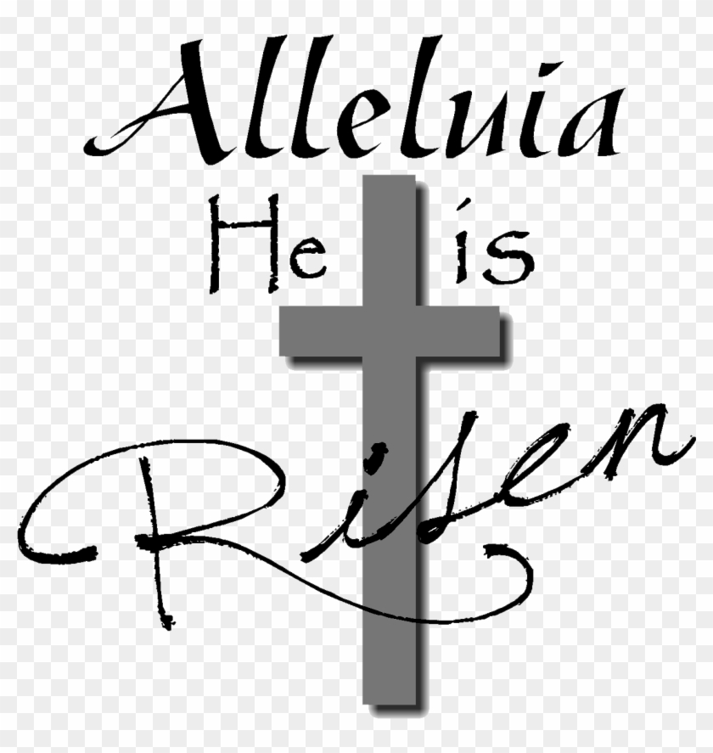

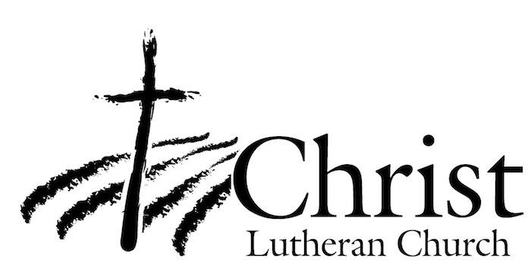
13009 N. Elderberry Ct.
Lodi, CA 95242
www.christlodi.org
209-368-6250
WELCOME TO CHRIST EV. LUTHERAN CHURCH!
We preach a message of forgiveness, hope and peace
through the death and resurrection of Jesus Christ.
Families and individuals of all ages will find opportunities
both to grow and to serve.

Our mission statement:
Look what Christ is doing!
He binds us together in fellowship
He gathers us in for worship
He builds us up for service
He sends us out with the gospel

“Now you are the body of Christ,
and each one of you is a part of it.”
(1 Corinthians 12:27)

